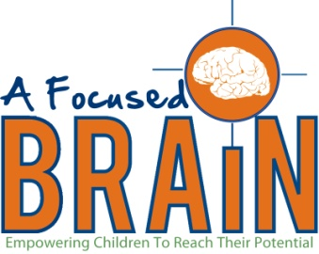 Therapy Referral
A Focused Brain
7712 Old Canton Road - Suite B
Madison, MS 39110
Phone: (601) 427-5775 Fax: (601) 206-0668

Patient Name: ____________________________________ DOB_____________________________

Reason For Referral: (check One) □ Occupational Therapy □ Physical Therapy

Treatment: Evaluate and Treat

Frequency: 3 times per week Duration: 6 months

Diagnosis: ICD-10 Codes:
______________________________________ ___________________________________
______________________________________ ___________________________________
______________________________________ ___________________________________

Precautions: ____________________________________________________________________________________________________________________________________________________________________________________

Requested by: ____________________________________, M.D Request Date: _____________________
(Signature)

______________________________________ Phone Number: _____________________
(Print Name)

______________________________________
(NPI Number)

